PSYC 5210 Exam 1

Submitted by: Prateek Kumar

Contents

Problem 1 2

What was the effect of time of day on RT and accuracy? 2

What was the effect of session on RT and accuracy? 2

What was the effect of the correct response side (i.e., order) on RT and accuracy? 4

Was there improvement in RT/accuracy within a session? Answer this both overall, and for only session 1. 5

Categorize the sessions into three session blocks: 1-4, 5-8, and 9-12. What was the effect of time of day and session block (i.e., a 4x3 table) on RT and accuracy? 6

Problem 2 8

Problem 3 10

Subnum = 222 10

Subnum = 2JT 11

Subnum = 3001 11

Subnum = 312 11

Subnum = 327 11

Subnum = C47 11

Subnum = EJS 12

Subnum = Z13 12

APPENDIX (R Script File) 12

# Problem 1

* Here in problem 1 we are doing our analysis on rt (response time, in milliseconds) and corr (accuracy, with correct responses coded as 1 and incorrect as 0.)
* For each question we are doing our analysis based upon the mean and std. dev.
* Explaining the two terms:
* Response Time: The length of time taken for a person or system to react to a given stimulus or event.
* Accuracy: The state of being correct.
* So explaining about mean with respect to response time we can say that if the mean is smaller the person is more reactive towards an event i.e. he/ she has taken less time to react for the event on an average and similarly for accuracy we can say that more the mean value is close to 1 the person is more accurate.
* And the standard deviation indicates that the data points tend to be close to the mean (also called the expected value) of the set, while a high standard deviation indicates that the data points are spread out over a wider range of values.

## What was the effect of time of day on RT and accuracy?

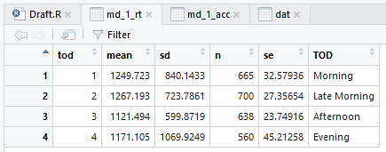

Figure : Time of day and Response Time

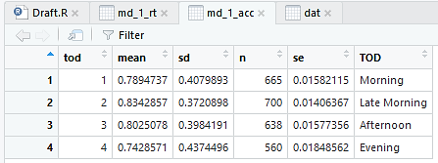

Figure :Time of day and Accuracy

* We have 4 time of day: 1=morning, 2=late morning 3= afternoon 4=evening.
* On looking at Fig. 1 at the four mean values and the sd values we can say that people are more active during the afternoon because the mean and sd values of the response time are lowest for the afternoon.
* But while looking at Fig. 2 we can say that people are much more accurate in Late Morning than the remaining 3 times of day because the mean value is closest is to 1 and the sd value is also the least.

## What was the effect of session on RT and accuracy?

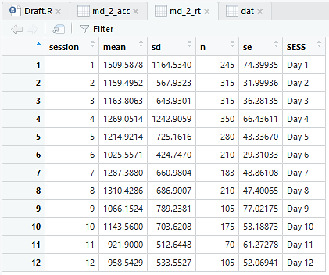

Figure : Session and Response Time

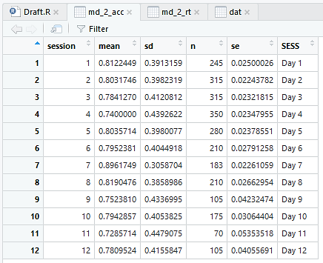

Figure : Session and Accuracy

* We have 12 sessions: Session refers to the day sample was taken.
* On looking at Fig. 3 at the mean values and the sd values we can say that people are most active during the last 2 days i.e. on Day 11 and followed by Day 12 because the mean and sd values of the response time are lowest for them.
* But while looking at Fig. 4 we can say that people are most accurate on Day 7 and followed by Day 8 because the mean value is closest is to 1 and the sd value is also the least.

## What was the effect of the correct response side (i.e., order) on RT and accuracy?

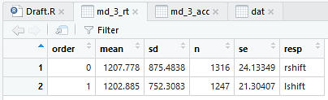

Figure : Order and Response Time

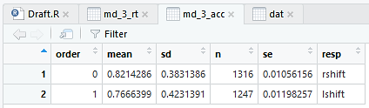

Figure : Order and Accuracy

* Order refers to whether the correct stimulus was on the left or right (and thus whether the correct response was left-shift or right-shift). So basically we have 2 orders.
* On looking at Fig. 5 at the two mean values and the sd values we see that mean and sd values of the response time is less for left-shift so it has less response time.
* But looking at Fig. 6 we can say that accuracy for right-shift is more because the mean value is closest is to 1 and the sd value is also the least.
* The above two results are absolutely correct if we want the precise effect of the correct response side (i.e., order) on RT and accuracy but when we see both the tables we actually do not see much of a difference in both the response sides so we can conclude that the RT and accuracy are evenly distributed on both the left and right stimulus.

## Was there improvement in RT/accuracy within a session? Answer this both overall, and for only session 1.

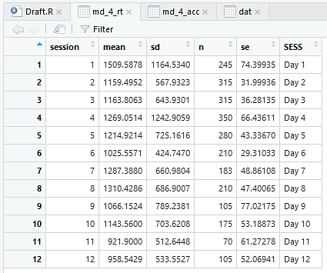

Figure : Session and Response Time

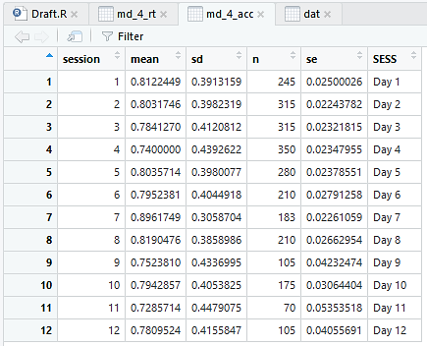

Figure : Session and Accuracy

* We have 12 sessions: Session refers to the day sample was taken.
* On looking at Fig. 7 at the mean values and the sd values we can say that definitely there is improvement in the response time and the accuracy as the day progresses because for session 1/ Day 1 we have the highest mean value which means that the response time is worse with respect to other days and also the sd is very high which means people have different response times. But on looking at Fig. 8 we see that although the response time is high the accuracy is somewhat better than rest of the days. So overall we can say that the response time has improved over the days but the accuracy is more or less the same.
* With respect to session 1 we can say that the response time is better on the last days i.e. on day 11 and day 12 so the response time has been improved but the accuracy is somewhat same for all the days but there is much difference on day 7 and day 11 where people are most accurate and where people are least accurate respectively.

## Categorize the sessions into three session blocks: 1-4, 5-8, and 9-12. What was the effect of time of day and session block (i.e., a 4x3 table) on RT and accuracy?

* We have 4 time of day: 1=morning, 2=late morning 3= afternoon 4=evening.

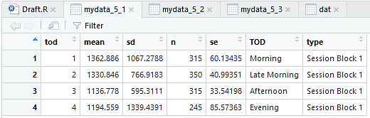

Figure : Time of day and Session Block 1 with Response Time

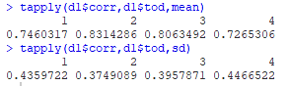

Figure : Time of day and Session Block 1 with Accuracy

* From day 1 to day 4:
* On looking at Fig. 9 at the four mean values and the sd values we can say that people are more active during the afternoon because the mean and sd values of the response time are lowest for the afternoon.
* But while looking at Fig. 10 we can say that people are much more accurate in Late Morning than the remaining 3 times of day because the mean value is closest is to 1 and the sd value is also the least.

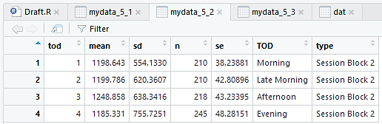

Figure : Time of day and Session Block 2 with Response Time

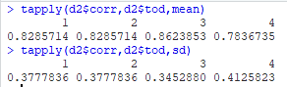

Figure : Time of day and Session Block 2 with Accuracy

* From day 5 to day 8:
* On looking at Fig. 11 at the four mean values and the sd values we can say that people are more active during the evening because the mean value of the response time lowest for the evening.
* But while looking at Fig. 12 we can say that people are much more accurate in Afternoon than the remaining 3 times of day because the mean value is closest is to 1 and the sd value is also the least.

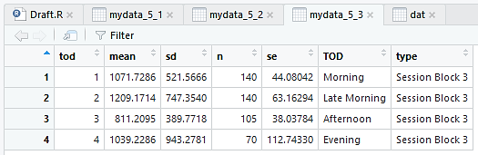

Figure : Time of day and Session Block 3 with Response Time

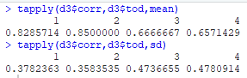

Figure : Time of day and Session Block 3 with Accuracy

* From day 9 to day 12:
* On looking at Fig. 13 at the four mean values and the sd values we can say that people are more active during the afternoon because the mean and sd values of the response time are lowest for the afternoon.
* But while looking at Fig. 24 we can say that people are much more accurate in Late Morning than the remaining 3 times of day because the mean value is closest is to 1 and the sd value is also the least. And moreover people are least accurate during the afternoon.

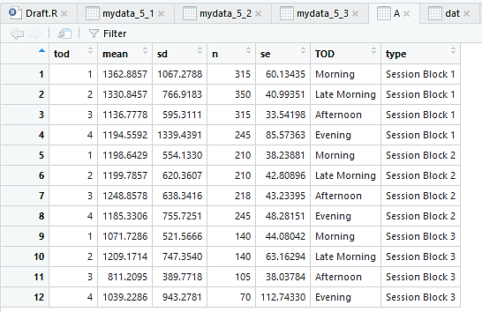

Figure : Time of day and all Session Blocks with Response Time

# Problem 2

* Rather than plotting with respect to response time I have plotted based on mean response time in order to depict the similar scenario of Q1.

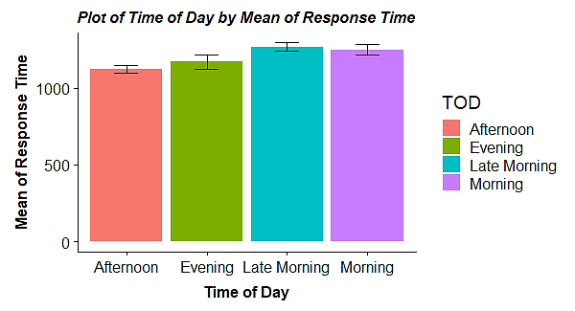

Figure : In this figure I have plotted a Bar chart with error bars specifying standard error on Mean of Response Time and Time of Day. The error bars are the 4 time of day (Morning, Late Morning, Afternoon & Evening) and their length gives us the idea of their Mean of Response Time. On the top of each bar chart I have plotted the error bars which gives us the idea of standard error.

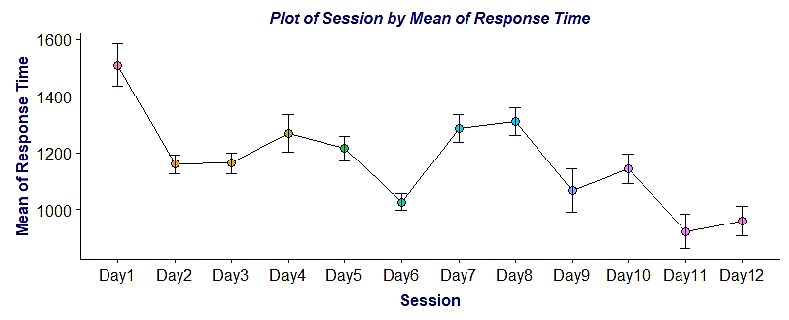

Figure : In this figure I have plotted a matplot with error bars specifying standard error on Mean of Response Time and Session. The session here are the days when the sample was taken and the dots give us the idea of their Mean of Response Time. On each point I have plotted the error bars which gives us the idea of standard error.

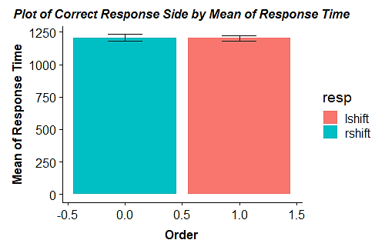

Figure : In this figure I have plotted a Bar chart with error bars specifying standard error on Mean of Response Time and Order. The error bars are the 2 orders (Left-Shift & Right-Shift) and their length gives us the idea of their Mean of Response Time. On the top of each bar chart I have plotted the error bars which gives us the idea of standard error.

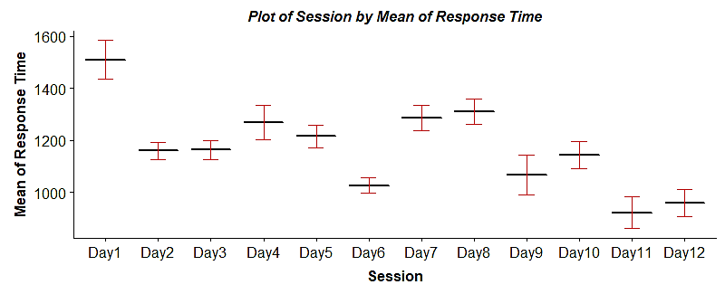

Figure : In this figure I have plotted the Box plots specifying standard error on Mean of Response Time and Session. The session here are the days when the sample was taken and the horizontal lines give us the idea of their Mean of Response Time. The whiskers of the boxplots give us the idea of standard error.

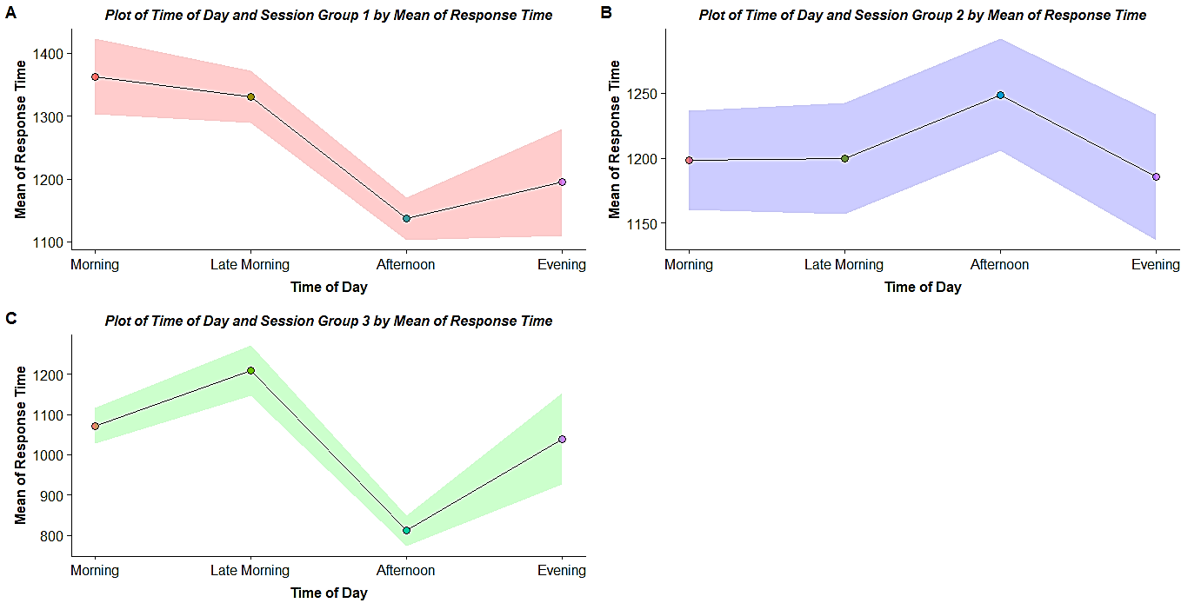

Figure : In this figure I have plotted the Band Plots of Mean of Response Time and Time of day for the 3 Session groups. The points on each band plot is the 4 time of day (Morning, Late Morning, Afternoon & Evening) plotted on their Mean of Response Time. The coloured areas around the points gives us the idea of standard error.

# Problem 3

## Subnum = 222

* Plot output



* Console Output



## Subnum = 2JT

* Plot output



## Subnum = 3001

* Plot output



## Subnum = 312

* Plot output



* Console Output



## Subnum = 327

* Plot output



* Console output

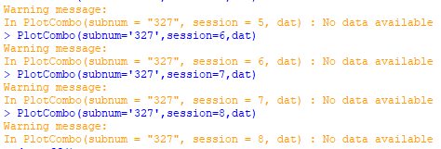

## Subnum = C47

* Plot output



* Console output



## Subnum = EJS

* Plot output



* Console output

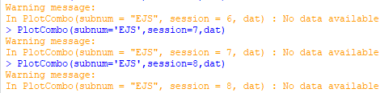

## Subnum = Z13

* Plot output



# APPENDIX (R Script File)

